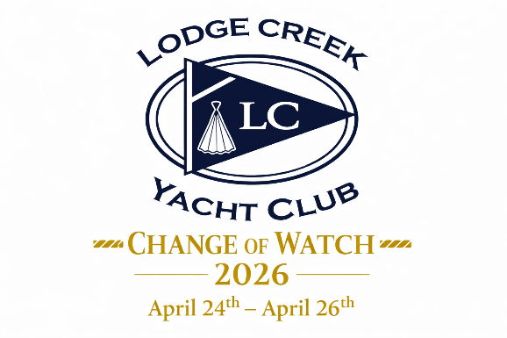

Change of Watch Weekend Schedule of Events:
- Friday, April 24
  - 6:00–9:00 PM Commodore’s Reception LCYC Pavilion (at the Marina)
- Saturday, April 25
  - 2:00–3:00 PM 2026 Bridge Annual Meeting (at the Marina Clubhouse)
  - 6:00–11:00 PM Change of Watch Dinner & Dance (at Callao Moose Lodge)
    - 968 Northumberland Highway, Callao, VA
- Sunday, April 26
    - 10:00–11:30 AM – Blessing of the Fleet, Flag Raising & Breakfast
Join us for an exciting evening of celebration and entertainment!
- A self-serve/open bar will be available for our guests.
- Please note: Guests are asked to bring their own liquor. Mixers will be provided.
- Beer must be purchased directly from the Moose Lodge Bar.
- Enjoy a buffet-style dinner featuring: Beef, Chicken, and Shrimp entrées with seasonal vegetables, house salad with assorted dressings, and a dessert
Program Highlights
Change of Watch Ceremony – Induction of the 2026 Bridge
Live entertainment by The Phun Doctors — our first live band in many years!
We look forward to celebrating together a truly memorable weekend.

Note: We look forward to celebrating together for a truly memorable weekend. The registration fee includes the Commodore’s Reception on Friday evening, a special dinner, the Change of Watch Ceremony, live music entertainment, Sunday breakfast, the Blessing of the Fleet, and the Flag Raising Ceremony
Please Select only one option below:
☐ Friday Reception, COW Dinner & Dance: ________ x $55 = ________
☐ Friday Reception Only: ______ x $15 = _________
PLEASE PRINT:
Name (s) __________________________________________________________________________________
Contact Phone Number__________________________Email:_________________________________
Please return this form no later than April 6, 2026 with a check payable to LCYC and mail to:
Jamie Mullins, LCYC Treasurer 320 Tucker Point Lane Callao, VA 22435

