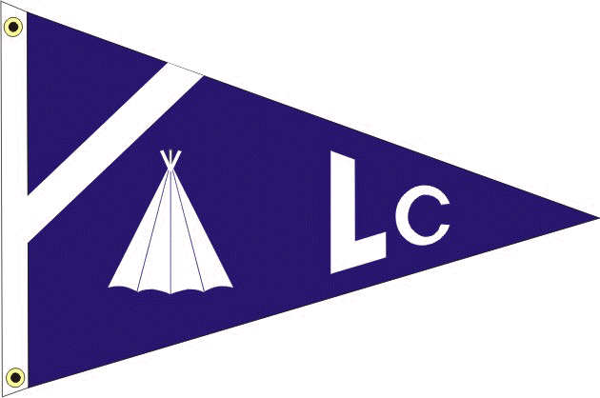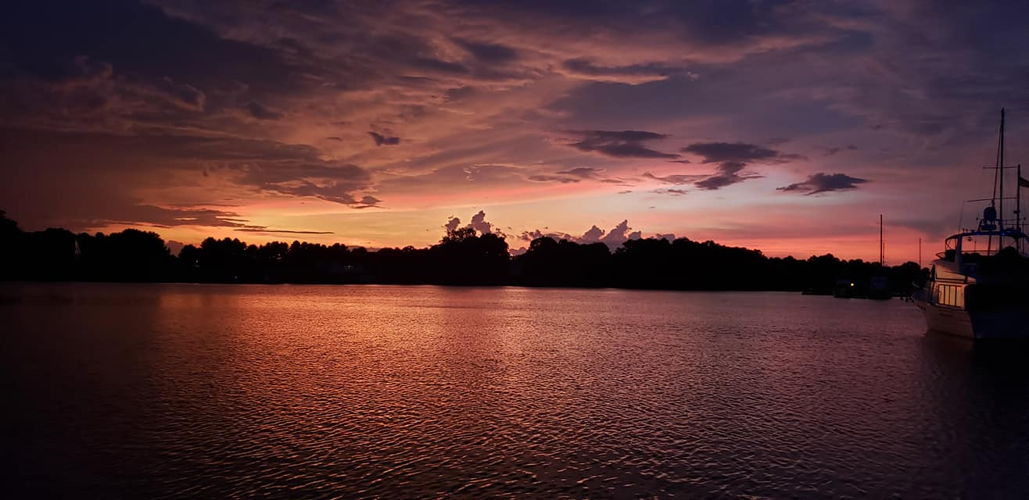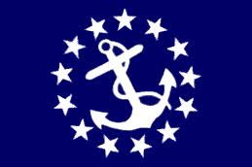
LODGE CREEK YACHT CLUB
November 2023 - newsletter
___________________________________________________________________________________________________________
___________________________________________________________________________________________________________
2024 BRIDGE
Commodore - Bobby Andrade
Vice Commodore - Rich Verdillo
Immediate Past Commodore - Antonia DePascale
Secretary - Theresa Sullivan
Treasurer - Jayne Miller
Fleet Captain - Heath Mullins
Ship Store - Lori Rappa
A-Dock Director - Ann Eichenmuller
B-Dock Director - Sue Eller
C-Dock Director - Laura Henson
D-Dock Director - Jamie Mullins
E-Dock Director - Bill Sullivan
Webmaster - Kenny DePascale

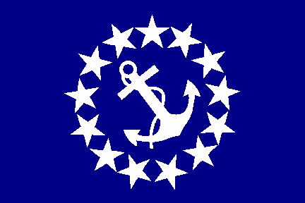 Commodore: BOBBY ANDRADE

Yup, you heard that correctly, it's not a typo. I, Bobby Andrade, Jr. (a/k/a "Bobbylite") will be your upcoming Commodore for the 2024 year. I will try to do my very best not to sink the ship? I have some big shoes to fill as my predecessors have set a high bar!

A special thanks to our Immediate Past Commodore, Antonia, for giving up her time and making 2023 a successful year for the LCYC.

I want to thank my Bridge for joining me as we collectively keep the LCYC tradition alive!!

Stay tuned for the upcoming newsletters and join us for a fresh year of fellowship and adventure!!

Bobbylite

 TREASURER: JAYNE MILLER

Thanks to everyone who participated in our dock events over the last year. We ended the year with a carryover of about $5,000. Please consider attending the Change of Watch in the spring. Attendance helps to keep the cost down and it is a lot of fun to see everyone again after the cold winter.

I am accepting payment of the dues for 2024. The renewal form can be found on our website or in the hallway in the Olverson’s Marina. At this point I have received renewal forms from 5 members. Dues are payable on December 1st until January 31, 2024. There is a $20 late fee after that date. Please remember that dues in arrears 60 days after January 1, 2024 are construed as a resignation of membership.

Jayne Miller, Treasurer

SECRETARY: theresa sullivan

I hope everyone had a great Thanksgiving! The Roster has been updated as of November 26th (this does not include any 2024 renewal updates). Please look it over to be sure all your information is correct so when you fill out your renewal forms you can make any necessary changes.

Please remember the dues have increased for the 2024 Season to $150. I know some members just send checks without the renewal forms because their information has not changed, so I wanted to be sure everyone is aware of the increase. The 2024 Roster will be updated as renewals come in.

The 2024 Event Calendar has been posted on the LCYC website and will also be posted around the marina.

Theresa Sullivan
Secretary, LCYC

FROM YOUR DOCK DIRECTORS

A DOCK DIRECTOR: ANN EICHENMULLER

My husband Eric and I retired to the Northern Neck from Southern Maryland in 2015. I spent the next seven years as a contributing writer for boating and RV magazines, with Eric as my photographer. Now we're finally ready to relax and really retire! We moved our sailboat, Avalon, to Olverson's in the winter of 2023 and are excited to be back on the Potomac, where we both learned to sail, and to be members of Lodge Creek Yacht Club. I am looking forward to getting to know everyone and participate in planning activities for the 2024 boating season.

Ann Eichenmuller
A Dock Director
B DOCK DIRECTOR: SUE ELLER

A big thank you to our outgoing Dock Director Rich Verdillo. He has done an outstanding job for the past few years and his shoes will be hard to fill. Congratulations to his big “promotion” to Vice Commodore. And a shout-out to everyone in the yacht club for a great 2023 boating season.

Winter cannot go by too quickly. Thanks to members of B Dock who have already decided on our theme for our 2024 function - Welcome to Margaritaville.
Hoping everyone has a nice holiday with family and friends.
Sue Eller
B Dock Director

D DOCK DIRECTOR: JAMIE MULLINS

Hope everyone is having a great holiday season!! It's colder and quieter at the marina, but the Rock Fish finally seem to be biting!! So bundle up & come on out to try your luck. Counting the days for the warmer weather and familiar faces at the docks!! It'll be here before we know it.

Jamie Mullins
D Dock Director

MESSAGE FROM DAVE TEETS - SAFETY OFFICER

BOATERS SAFE BOATING COURSE - Effective July 1, 2019 all Virginia boaters must have taken a Certified Boaters Safe Boating Course and have proof of this while boating in Virginia waters while operating any vessel powered by a motor of at least 10 hoursepower. This law makes no distinction of age or experience.

As we start the boating season, we must all renew our commitment for SAFE BOATING.

Spring Virginia Safe Boating Class
Saturday, June 15, 2024

If you are planning on operating a boat in Virginia waters that is 10hp or more, you are required to have taken a certified Boater Safety Course. Lodge Creek Yacht Club and Olverson’s Marina sponsor this one-day class and it’s free!!!

This 8-hour class will be offered on Saturday June 15, 2024 and comes with a lunch that is provided by the Marina! So, the class is free, and lunch is too!!

If you are operating a boat in Virginia waters, you are supposed to have a copy of your Boater Certification Card with you. If you don’t have it with you, Law Enforcement will ruin your day!!

Mark this date on your calendar, and plan on attending the class. Don’t forget the kids and grandkids who may be old enough to operate a boat, but don’t have the certification. Be sure that you contact the Marina Office to sign up for the class.

VESSEL SAFETY CHECKS - The most cautious boaters can sometimes experience unexpected problems on the water. That's why the U.S. Coast Guard recommends that all recreational boaters, including personal watercraft and paddle sport users take advantage of the free Vessel Safety Check Program every year.

Remember, try to obtain a VSC exam before the boating to help insure your safety throughout the boating season. These examiners provide a lot of useful information and can help you with many of your boating questions also!!!

What’s in it for me??
Vessels passing safety checks are awarded a U.S. Coast Guard Decal that informs all law enforcement agencies that your boat was in full compliance with all Federal and State boating laws during a safety check for a particular year. Best of all…its free of charge!!

Why Receive a Vessel Safety Check??
Safety!! The peace of mind that your boat meets federal safety standards and that in an emergency you will have the necessary equipment to save lives and summon help!

Where do I get a Vessel Safety Check?
All those who are at Olverson’s Marina are eligible for a Vessel Safety Check. There are two certified examiners located at the Marina and are available for a VSC. Jim Zeigler and Dave Teets are certified examiners and are members of Lodge Creek Yacht Club as well. While their boats are located on C-Dock, feel free to call them or let them know you want one. Their information is located in the LCYC Directory.

How long does it take?
Generally, the Vessel Safety Check takes about 20 minutes and if your boat passes, then you are awarded the VSC sticker immediately and it is valid for the rest of the calendar year.

The new 2024 VSC stickers should be available in late January, so be sure to put this project on your “to do” list for the new boating season!!

Dave Teets
Past Commodore/Safety Officer

_______________________________________________________________________________________

IMPORTANT INFORMATION TO REMEMBER

MEMBERSHIP RENEWAL

THE FISCAL YEAR FOR LCYC RUNS FROM DECEMBER 1ST THRU NOVEMBER 30TH OF THE FOLLOWING YEAR.

Dues renewal forms are due December 1st and collected thru January 31st, without a penalty fee. Renewals paid after the that date are subject to a late fee of $20 and are payable for the next 60 days. After that date per Article V, Section 3D, failure of payment is construed as resignation of membership and I am required to notify the ex-member in writing of the termination. Per Section 3F, payment of delinquent dues and a reinstatement fee equal to 1/3 of the annual dues made by the ex-member and the acceptance of and reinstatement shall be the sole discretion of the Board of Directors and decided by a majority vote.

An invoice is not sent for the dues collection, the Secretary has graciously sent reminders with an attachment of the renewal form for your convenience prior to the due date of December 1 and often a second reminder prior to the January 31 date. The renewal form can also be found on our website.

LCYC Website link: https://www.lodgecreekyachtclub.com. For quick access to the Roster and dock assignments the link is: http://www.lodgecreekyachtclub.com/members/ (Password Protected) You do not need to make your own password. Please reach out to Theresa at theresasullivan6188@gmail.com if you need the password or to me at webmaster@lodgecreekyachtclub.com.

-Kenny D, LCYC Webmaster

