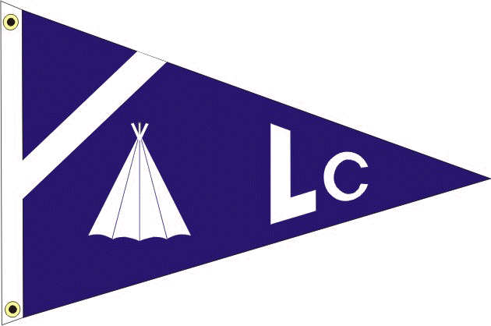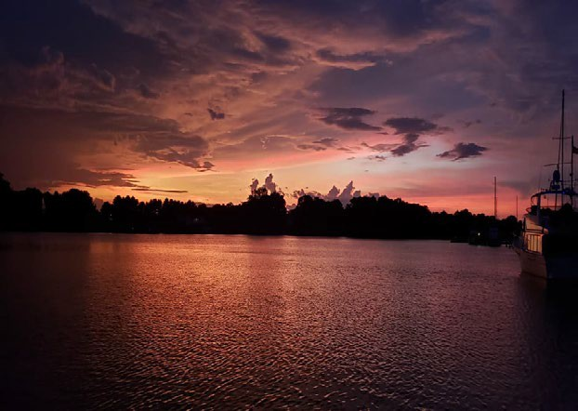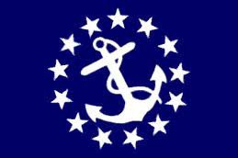

LODGE CREEK YACHT CLUB JULY/AUGUST 2023 - mOnTHLY nEwSLETTER

2023 BRIDGE
Commodore - Antonia DePascale Vice Commodore - Bobby Andrade
Immediate Past Commodore - Bill Sullivan Secretary - Theresa Sullivan
Treasurer - Jayne Miller Fleet Captain - Heath Mullins
Ship Store - Lori Rappa
A-Dock Director - n/a
B-Dock Director - Rich Verdillo
C-Dock Director - Laura Henson
D-Dock Director - Kenny DePascale
E-Dock Director - Alex Rappa

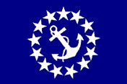
COMMODORE: ANTONIA DEPASCALE

I want to say thank you to everyone who was able to come down to the Marina for our Christmas in July Dock Crawl. All of the docks did an amazing job with their decorations and food as always!

Our next function will be our Bridge Function on August 19th. We will be having a cookout by the pool! We will also have a 12' Water slide set up! Somehow summer is flying by and it is already August.

We have a few functions left to finish off the year strong! Look forward to seeing y'all at the pool party.

The Roster has been updated, please be sure to look it over and let Theresa know if any changes need to be made. Thanks!

Your commodore, Antonia

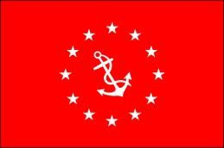
VICE COMMODORE: BOBBY ANDRADE

Well, well sweet summertime is in full swing! Gotta love.

Big shout out to our fleet captain for popping his cherry on the first beach party of the year! Where even the jellyfish had their fill on LCYC 

Don’t pack your swim suit just yet as there will be a pool party in the mist shortly! See y’all there!
Bobbylite


FROM YOUR DOCK DIRECTORS

D DOCK DIRECTOR: KENNY DEPASCALE

Well it's been an eventful past few weeks at the marina with lots of fun events going on. So much so that we forgot to send a July newsletter. :)

The Pirate Beach Float In was a blast with approximately 30 people in attendance. It was a beautiful sunny day, the water was warm, and the food was great (how about those burgers?!). While the jellyfish came and stung us out of our good times, it was still plenty long to get a good sunburn and spend time with great friends.

Don't forget about the August Bridge Function coming up in just a few short weeks. I apologize about getting the event notification and registration page up on the website so late, but like most of us, there's a lot going on personally and professionally at the moment and at the end of the day, this is a fun thing for all of us. I do hope to see you all there so that we can keep the good times rolllin'!

Kenny D
D Dock Director

WEBMASTER REPORT

LCYC Website link: https://www.lodgecreekyachtclub.com. For quick access to the Roster and dock assignments the link is: http://www.lodgecreekyachtclub.com/members/ (Password Protected) You do not need to make your own password. Please reach out to Theresa at theresasullivan6188@gmail.com if you need the password or to me at webmaster@lodgecreekyachtclub.com.

-Kenny D, LCYC Webmaster

IMPORTANT INFORMATION TO REMEMBER

MEMBERSHIP RENEWAL

THE FISCAL YEAR FOR LCYC RUNS FROM DECEMBER 1ST THRU NOVEMBER 30TH OF THE FOLLOWING YEAR.

Dues renewal forms are due December 1st and collected thru January 31st, without a penalty fee. Renewals paid after the that date are subject to a late fee of $20 and are payable for the next 60 days. After that date per Article V, Section 3D, failure of payment is construed as resignation of membership and I am required to notify the ex-member in writing of the termination. Per Section 3F, payment of delinquent dues and a reinstatement fee equal to 1/3 of the annual dues made by the ex-member and the acceptance of and reinstatement shall be the sole discretion of the Board of Directors and decided by a majority vote.

An invoice is not sent for the dues collection, the Secretary has graciously sent reminders with an attachment of the renewal form for your convenience prior to the due date of December 1 and often a second reminder prior to the January 31 date. The renewal form can also be found on our website.

BOATERS SAFE BOATING COURSE - Effective July 1, 2019 all Virginia boater must have taken a Certified Boaters Safe Boating Course and have proof of this while boating in Virginia waters while operating any vessel powered by a motor of at least 10 hoursepower. This law makes no distinction of age or experience.

As we start the boating season, we must all renew our commitment for SAFE BOATING.

VESSEL SAFETY CHECKS - The most cautious boaters can sometimes experience unexpected problems on the water. That's why the U.S. Coast Guard recommends that all recreational boaters, including personal watercraft and paddle sport users take advantage of the free Vessel Safety Check Program every year. We have certified Vessel Safety Check Examiners here at Olverson's Marina. Please contact the Marina Office and office personnel will provide you with contact information for getting this free examination. Once you have completed this free 15-minute examination, you will be given a decal that can proudly be displayed on your vessel. Taking a few minutes to have your vessel checked, just may save you from problems this season!

Vessel Safety Checks are FREE and very important for all boaters to obtain one each season! Once you pass a VSC, you receive a certification sticker that is displayed on your boat and shows law enforcement that your vessel has passed for the 2023 boating season. To learn more about a Vessel Safety Check, feel free to talk with the two Certified VSE examiners that are based out of Lodge Creek Yacht Club-Jim Zeigler (C-22) and Dave Teets (Southern Cross – 804-370-7061) (C-24). Your boat needs to have Coast Guard safety equipment on board along with proper registration or documentation. Navigation lights and your boat horn need to be working as well.

Contacting the Marina Office, or Dave (804-370-7061) or (804-347-5239), is all you need to do to get an examination at your convenience. Remember, try to obtain a VSC exam before the boating to help insure your safety throughout the boating season. These examiners provide a lot of useful information and can help you with many of your boating questions also!!!

