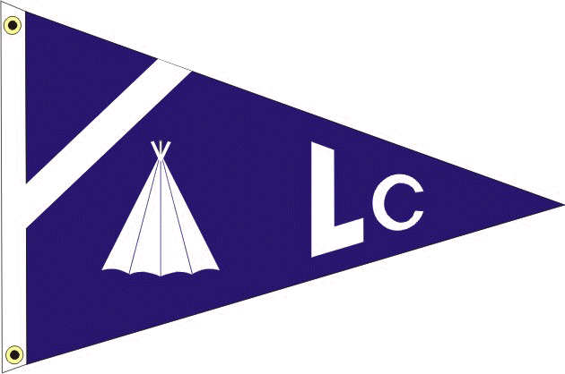
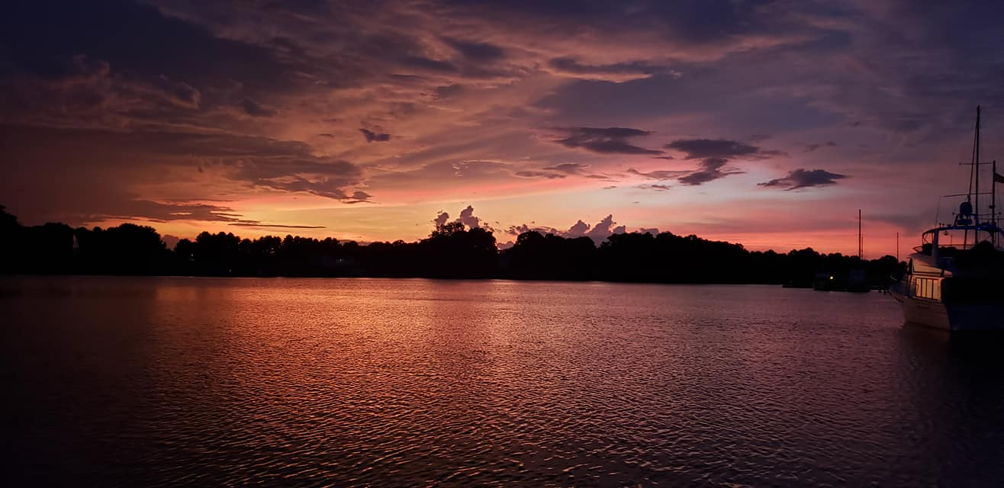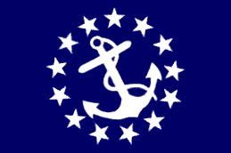
LODGE CREEK YACHT CLUB
june 2023 - monthly newsletter
___________________________________________________________________________________________________________
___________________________________________________________________________________________________________
2023 BRIDGE

Commodore - Antonia DePascale
Vice Commodore - Bobby Andrade
Immediate Past Commodore - Bill Sullivan
Secretary - Theresa Sullivan
Treasurer - Jayne Miller
Fleet Captain - Heath Mullins
Ship Store - Lori Rappa
A-Dock Director - n/a
B-Dock Director - Rich Verdillo
C-Dock Director - Laura Henson
D-Dock Director - Kenny DePascale
E-Dock Director - Alex Rappa

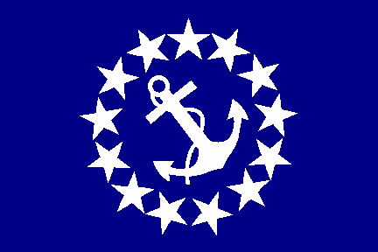 Commodore: antonia depascale

Summer is now in full swing! We had a great turn out for C-Dock's St. Paddy's Day in June. I am looking forward to seeing everyone for our Christmas in July Dock Crawl on July 1st. All docks break out your best Christmas decorations as there will be a prize for the best decorated dock! We will also have the ice cream social on July 2nd so make sure you join us up at the club house for that! Looking forward to seeing you all soon!

Your commodore,
Antonia

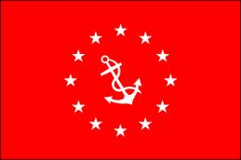 vice commodore: bobby andrade

Sweet summertime is finally here! I don’t know about you but I’m looking forward to some good days in and around the river, as well as the upcoming pirate and shark beach outings!! Whine my boat is in the hard having some much needed repairs, hope to get her back in action asap. Cheers to sunburn aloe and ice cold beer! Bobbylite vice
FROM YOUR DOCK DIRECTORS

B DOCK DIRECTOR: RICH VERDILLO

I would like to first thank all my Worker B's for the great job they did putting on our Celebration of Secretariats 50th Anniversary of his historic Triple Crown Campaign. I think everyone had a good time and enjoyed the races. Speaking of races, how about those Dock Jockeys? They must have been training for months to be able to turn in such impressive performances.

I'm writing this the morning after another great dock function. C Dock really knocked it out of the park with their Irish Celebration. Great food, great beer, great limericks, and just an all-around good time.

The weather is finally turning in our favor, so I hope to see you on the water soon.

Rich V
B Dock Director

C DOCK DIRECTOR: LAURA HENSON

First, I would like to give a "kudos' and a big "Thank you " to Kenny. Kenny was very helpful with updates and keeping me informed as a new dock director. He even added some fun Irish pictures to the reminder of the C Dock event. He is such fun to guy to work with and knows his stuff! Thank you Kenny!!

Second, I want to say "thank you" to all my C Dock peeps. We had a great time, great food, and a wonderful variety of appetizers. C Dock is a fun and happening group of boaters. We already have several thoughts about next year's C Dock event ideas. So thank you guys!

Laura
C Dock Director

D DOCK DIRECTOR: KENNY DEPASCALE

Can you believe it's almost Fourth of July weekend already?! It's been a hectic month personally for the Commodore and myself, but hopefully that's all past us now and we can spend more time at the marina in the upcoming weeks. Especially so since the holiday weekend is nearly upon us, and the Pirate Beach function isn't too far behind that.

Don't forget about the "Christmas in July" Dock Crawl on Saturday July 1st, and the Ice Cream social the very next day on Sunday July 2nd. The Dock Crawl last year was a huge success, and we think it's going to be even better this year! D Dock will be serving up Beef Brisket Sliders and Pineapple Upside-Down drinks for our specialty cocktail, so be sure to stop by and get you some!

-Kenny D
D Dock Director

WEBMASTER REPORT

LCYC Website link: https://www.lodgecreekyachtclub.com. For quick access to the Roster and dock assignments the link is: http://www.lodgecreekyachtclub.com/members/ (Password Protected) You do not need to make your own password. Please reach out to Theresa at theresasullivan6188@gmail.com if you need the password or to me at webmaster@lodgecreekyachtclub.com.

-Kenny D, LCYC Webmaster
REMINDERS

The Richmond Sail and Power Squadron invites Lodge Creek members to participate in a cruise to Norfolk, Hampton and Yorktown. The first organized activities will be July 3 at Tidewater Marina across from Waterside and you can join us for a Norfolk Tides Ball Game. July 4th fireworks will be directly overhead. The group will then move to Bluewater Yachts in Hampton on July 5 and Riverwalk Landing in Yorktown on July 7, returning home on the 9th. If you are interested, contact Jim Zeigler at 804-347-5239 or jim@jpzeigler.com.

_______________________________________________________________________________________

IMPORTANT INFORMATION TO REMEMBER

MEMBERSHIP RENEWAL

THE FISCAL YEAR FOR LCYC RUNS FROM DECEMBER 1ST THRU NOVEMBER 30TH OF THE FOLLOWING YEAR.

Dues renewal forms are due December 1st and collected thru January 31st, without a penalty fee. Renewals paid after the that date are subject to a late fee of $20 and are payable for the next 60 days. After that date per Article V, Section 3D, failure of payment is construed as resignation of membership and I am required to notify the ex-member in writing of the termination. Per Section 3F, payment of delinquent dues and a reinstatement fee equal to 1/3 of the annual dues made by the ex-member and the acceptance of and reinstatement shall be the sole discretion of the Board of Directors and decided by a majority vote.

An invoice is not sent for the dues collection, the Secretary has graciously sent reminders with an attachment of the renewal form for your convenience prior to the due date of December 1 and often a second reminder prior to the January 31 date. The renewal form can also be found on our website.

BOATERS SAFE BOATING COURSE - Effective July 1, 2019 all Virginia boater must have taken a Certified Boaters Safe Boating Course and have proof of this while boating in Virginia waters while operating any vessel powered by a motor of at least 10 hoursepower. This law makes no distinction of age or experience.

As we start the boating season, we must all renew our commitment for SAFE BOATING.

VESSEL SAFETY CHECKS - The most cautious boaters can sometimes experience unexpected problems on the water. That's why the U.S. Coast Guard recommends that all recreational boaters, including personal watercraft and paddle sport users take advantage of the free Vessel Safety Check Program every year. We have certified Vessel Safety Check Examiners here at Olverson's Marina. Please contact the Marina Office and office personnel will provide you with contact information for getting this free examination. Once you have completed this free 15-minute examination, you will be given a decal that can proudly be displayed on your vessel. Taking a few minutes to have your vessel checked, just may save you from problems this season!

Vessel Safety Checks are FREE and very important for all boaters to obtain one each season! Once you pass a VSC, you receive a certification sticker that is displayed on your boat and shows law enforcement that your vessel has passed for the 2023 boating season. To learn more about a Vessel Safety Check, feel free to talk with the two Certified VSE examiners that are based out of Lodge Creek Yacht Club-Jim Zeigler (C-22) and Dave Teets (Southern Cross – 804-370-7061) (C-24). Your boat needs to have Coast Guard safety equipment on board along with proper registration or documentation. Navigation lights and your boat horn need to be working as well.

Contacting the Marina Office, or Dave (804-370-7061) or (804-347-5239), is all you need to do to get an examination at your convenience. Remember, try to obtain a VSC exam before the boating to help insure your safety throughout the boating season. These examiners provide a lot of useful information and can help you with many of your boating questions also!!!

