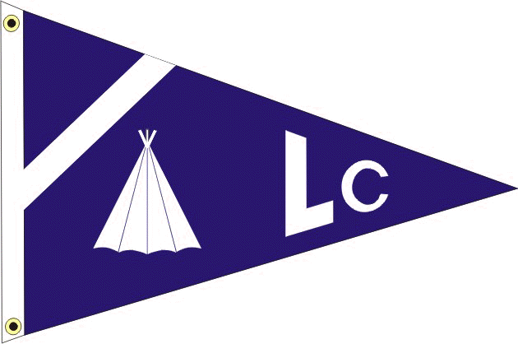
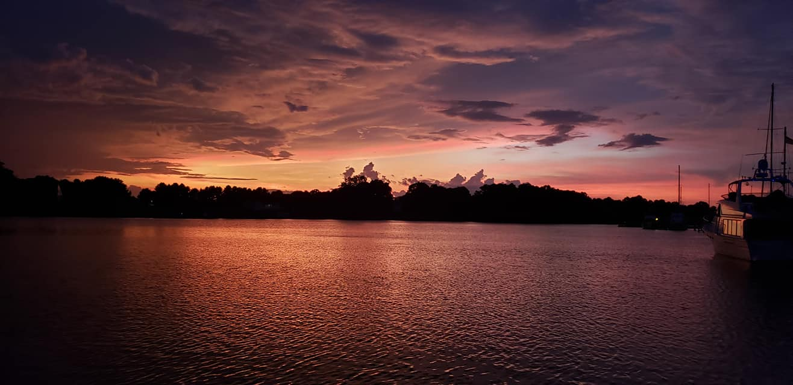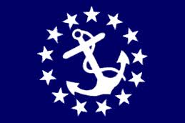
LODGE CREEK YACHT CLUB
MAY 2023 - monthly newsletter
___________________________________________________________________________________________________________
___________________________________________________________________________________________________________
2023 BRIDGE

Commodore - Antonia DePascale
Vice Commodore - Bobby Andrade
Immediate Past Commodore - Bill Sullivan
Secretary - Theresa Sullivan
Treasurer - Jayne Miller
Fleet Captain - James (Coach) Pulchine
Ship Store - Lori Rappa
A-Dock Director - n/a
B-Dock Director - Rich Verdillo
C-Dock Director - Laura Henson
D-Dock Director - Kenny DePascale
E-Dock Director - Alex Rappa

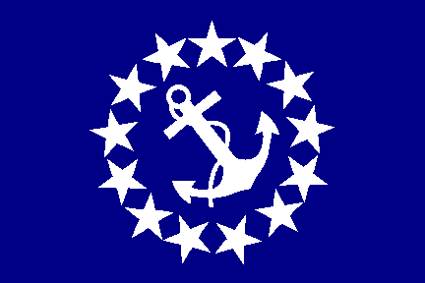 Commodore: antonia depascale

Well the start of the season kicked off with our Pot Luck and Blessing of the fleet. Thank you to everyone who braved the weather and came out for our Potluck on Saturday. Special thanks to the Bridge for helping me put this all together. It was a great weekend with a great turn out.

The B-Dock function is May 20th this year. Rich and his dock members have an awesome function planned that you do not want to miss! Friendly reminder to respond to the evite which can now be located on the website!

So we can all start planning. We will be having a Dock Crawl on July 1st, and the theme for all will be Christmas in July! Let's break out those Christmas decorations and have our docks decorated for the occasion!

Your commodore,
Antonia

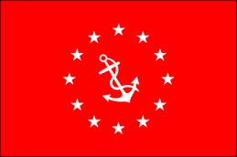 vice commodore: bobby andrade

Greetings and salutations fellow Yachty’s and jockeys!

B Dock's 59th Anniversary of Secretariats Triple Crown Campaign is upon us this weekend! I don’t know about you but our Jockey has been on strict workout regimen and dietary supplements aka ”beer and Doritos” and is ready to kick ass!!

Good luck because you’re gonna need it

Catch Y’all at D Rivah
Bobby Andrade, Jr.
__________________________________________________________________________________

TREASURER: JAYNE MILLER

At every function, during cocktail hour, please check in with me to get your name tags when you arrive at functions. This helps me to keep an attendance count.

I have been asked to make the membership aware of important information and dates that can be found in the LCYC By-Laws, available on our website.

The fiscal year for LCYC runs from December 1st thru November 30 of the following year. Dues renewal forms are due December 1st and collected thru January 31, without a penalty fee. Renewals paid after the that date are subject to a late fee of $20 and are payable for the next 60 days. After that date per Article V, Section 3D, failure of payment is construed as resignation of membership and I am required to notify the ex-member in writing of the termination. Per Section 3F, payment of delinquent dues and a reinstatement fee equal to 1/3 of the annual dues made by the ex-member and the acceptance of and reinstatement shall be the sole discretion of the Board of Directors and decided by a majority vote.

An invoice is not sent for the dues collection, the Secretary has graciously sent reminders with an attachment of the renewal form for your convenience prior to the due date of December 1 and often a second reminder prior to the January 31 date. The renewal form can also be found on our website.

The current balance in our checking account is $3,491.27, savings $5,005.01 and $100.00 cash.

The ships store has been restocked and inventory paid.

The Blessing of the Fleet weekend came in under budget and the rent for usage of the Club house has been paid.

Thanks to everyone for their continued support of the club, Jayne Miller, Treasurer

SHIP STORE: Lori rappa

All special orders received at the last function have been ordered and should be in by the C Dock function.

I will still be taking requests but they will probably not be ordered until closer to fall inventory time.

Ship store will be open at the functions during happy hour until dinner is served then will close for the evening.

Hope to see y'all soon.

Lori

FROM YOUR DOCK DIRECTORS

B DOCK DIRECTOR: RICH VERDILLO

Greetings,

B Dock is working hard and very excited to bring you the first dock function of the year. There is a flier attached with details and some may wonder about two titles for this event. Well, stuff happens and after all, It Ain't Nothing But A Party!! Be ready to bet on your favorite Dock Jockey as we will be running 4 races again the year.

We will need each dock to supply a jockey to represent you.

The menu will be sausage and pepper sandwiches, (just like last year), salads and dessert. And of course, appetizers for Happy Hour. So come help us celebrate the 50th Anniversary of Secretariats Triple Crown Campaign.

Looking forward to seeing you there

B Dock

C DOCK DIRECTOR: LAURA HENSON

C Dock's meeting is May 20th at 4:00 pm.

We need to decide what theme & food items for our upcoming C Dock event for June. If you are unable to attend, please e-mail your thoughts!”
Thanks,

Laura
C dock director
D DOCK DIRECTOR: KENNY DEPASCALE

As mentioned in my last month's update, there's been much going down on D Dock already in 2023. The boys rebuilt the dock near the Tiki Bar which was sagging a bit, and we've remodeled our "kitchen!" (Thanks to Alex on E Dock for the "donations"). It really looks good so come on, stop by, and check it out!

Many of us have been spring commissioning and doing some needed maintenance on our vessels, all in preparation for some days and nights out on the water, and of course, the Beach Party in June. The good weather and rockfish season is right around the corner (if not opened already by the time this newsletter hits your eyeballs), so get on down to the marina and make sure your stuff is ship-shape. And while you're down there, be sure to stop by D Dock to check out our renovations and have a drink!

Lastly, our D Dock member Heath would like to remind everyone about Shark Tooth Island located in the Nomini Bay. There is an annual permit fee of $250/year per family for access to Shark Tooth Island, but so long as your feet are in the water, you are free to walk the perimeter free of charge. There is a permit application form now on the LCYC website in case anyone is interested in obtaining one. D Dock is planning on a run to Shark Tooth Island sometime this summer, so if anyone is interested in joining, please stop by and chat with one of us about it.
See ya around the docks!

-Kenny D
WEBMASTER REPORT

Function registration is now live on the LCYC website! After many hours cussing at the computer and a lot of lessons learned, I've squared away all the email problems that were inherited when taking over this website and implemented a few new plugins to facilitate our function registration natively. All appears to be working well and I am getting the registrations for those of you who have already done so. If you haven't yet had a chance to register for the B Dock function on May 20th, please stop by https://www.lodgecreekyachtclub.com. To register, click on the "Upcoming Functions" link at the top. This will bring you to our calendar, where you will find the function listing. Simply click on the "Register" button, enter your first & last name, email address, and number of Adults & Kids in your party, and finally click "Submit." You will get an email confirmation upon successful registration. I have sent email flyers and links to all active members in the LCYC roster as of April 25. If you haven't received your email invite, please email me at webmaster@lodgecreekyachtclub.com with your name and I'll get one right over to you.

For the 2023 Dock Directors, please be aware that I am able to pull an Excel spreadsheet of registered members for your functions, along with separate counts for Adults & Kids. I will provide the spreadsheets as needed and in advance of your functions so you can prepare accordingly. If you ever need an update, please just email me at webmaster@lodgecreekyachtclub.com and I'll get the updated copy to you ASAP.

Currently I am working on uploading all the past LCYC newsletters to the website and creating pages to host them all. I should have this done by the end of May, and so long as that all goes well, there likely won't be any major updates to the website until we get closer to the fall/winter time. We're getting into the good weather here, and like most of you, my spring and summer is spent with a lot of time down at the marina and fitting in some drag racing here and there when I can. That said, there won't be a lot of free time to enhance the website, but I do plan on giving it a makeover sometime in the future. That said, this will likely be the last Webmaster update for a while, but if anyone has any suggestions or problems, feel free to chat me up about it at the marina or email at the Webmaster address above. Happy boating!

-Kenny D, LCYC Webmaster
REMINDERS

Don't Forget the Virginia Boating Safety Class is being held on May 27th from 8:00 am to 4:30 pm. This is free of charge and lunch will be provided, free of charge, courtesy of Olverson's Lodge Creek Marina!!!

Virginia Boater Certification Cards issued at the end of class!!

Any person, young or old, is required to carry a Boater Certification Card while operating any vessel 10hp or more on the waters of the Commonwealth of Virginia. You, your children, or grandchildren may currently not be certified-this is an excellent opportunity to get certified!!!

Contact the Marina office to register, or if you are "late to the party", you can just show up! We need everyone to be a "legal beagle" !!

If you have any questions regarding the class, simply give Dave Teets a call at 804-370.7061. Sign up for the class today !!!!

The Richmond Sail and Power Squadron invites Lodge Creek members to participate in a cruise to Norfolk, Hampton and Yorktown. The first organized activities will be July 3 at Tidewater Marina across from Waterside and you can join us for a Norfolk Tides Ball Game. July 4th fireworks will be directly overhead. The group will then move to Bluewater Yachts in Hampton on July 5 and Riverwalk Landing in Yorktown on July 7, returning home on the 9th. If you are interested, contact Jim Zeigler at 804-347-5239 or jim@jpzeigler.com.

_______________________________________________________________________________________

IMPORTANT INFORMATION TO REMEMBER

MEMBERSHIP RENEWAL

THE FISCAL YEAR FOR LCYC RUNS FROM DECEMBER 1ST THRU NOVEMBER 30TH OF THE FOLLOWING YEAR.

Dues renewal forms are due December 1st and collected thru January 31st, without a penalty fee. Renewals paid after the that date are subject to a late fee of $20 and are payable for the next 60 days. After that date per Article V, Section 3D, failure of payment is construed as resignation of membership and I am required to notify the ex-member in writing of the termination. Per Section 3F, payment of delinquent dues and a reinstatement fee equal to 1/3 of the annual dues made by the ex-member and the acceptance of and reinstatement shall be the sole discretion of the Board of Directors and decided by a majority vote.

An invoice is not sent for the dues collection, the Secretary has graciously sent reminders with an attachment of the renewal form for your convenience prior to the due date of December 1 and often a second reminder prior to the January 31 date. The renewal form can also be found on our website.

LCYC Website link: http://www.lodgecreekyachtclub.com. For quick access to the Roster and dock assignments the link is: http://www.lodgecreekyachtclub.com/members/ (Password Protected) You do not need to make your own password. Please reach out to Theresa at theresasullivan6188@gmail.com if you need the password.

BOATERS SAFE BOATING COURSE - Effective July 1, 2019 all Virginia boater must have taken a Certified Boaters Safe Boating Course and have proof of this while boating in Virginia waters while operating any vessel powered by a motor of at least 10 hoursepower. This law makes no distinction of age or experience.

As we start the boating season, we must all renew our commitment for SAFE BOATING.

VESSEL SAFETY CHECKS - The most cautious boaters can sometimes experience unexpected problems on the water. That's why the U.S. Coast Guard recommends that all recreational boaters, including personal watercraft and paddle sport users take advantage of the free Vessel Safety Check Program every year. We have certified Vessel Safety Check Examiners here at Olverson's Marina. Please contact the Marina Office and office personnel will provide you with contact information for getting this free examination. Once you have completed this free 15-minute examination, you will be given a decal that can proudly be displayed on your vessel. Taking a few minutes to have your vessel checked, just may save you from problems this season!

Vessel Safety Checks are FREE and very important for all boaters to obtain one each season! Once you pass a VSC, you receive a certification sticker that is displayed on your boat and shows law enforcement that your vessel has passed for the 2023 boating season. To learn more about a Vessel Safety Check, feel free to talk with the two Certified VSE examiners that are based out of Lodge Creek Yacht Club-Jim Zeigler (C-22) and Dave Teets (Southern Cross – 804-370-7061) (C-24). Your boat needs to have Coast Guard safety equipment on board along with proper registration or documentation. Navigation lights and your boat horn need to be working as well.

Contacting the Marina Office, or Dave (804-370-7061) or (804-347-5239), is all you need to do to get an examination at your convenience. Remember, try to obtain a VSC exam before the boating to help insure your safety throughout the boating season. These examiners provide a lot of useful information and can help you with many of your boating questions also!!!

