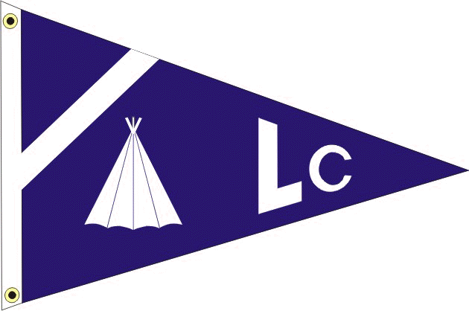
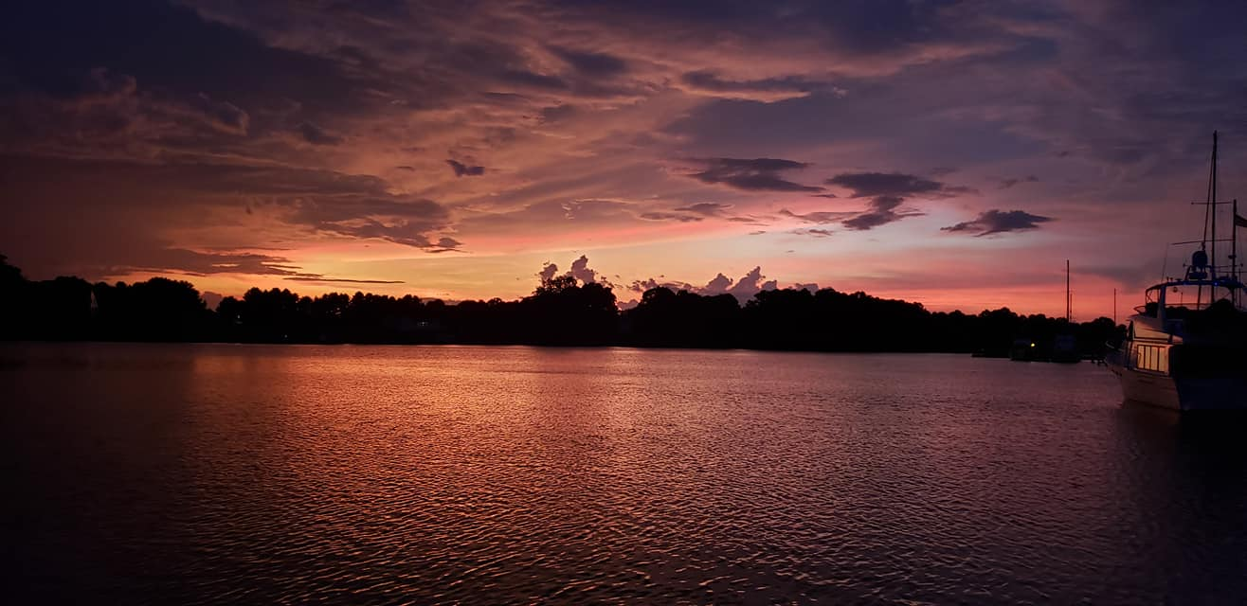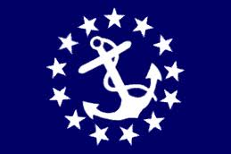
LODGE CREEK YACHT CLUB
April 2023 - monthly newsletter
___________________________________________________________________________________________________________
___________________________________________________________________________________________________________
2023 BRIDGE

Commodore - Antonia DePascale
Vice Commodore - Bobby Andrade
Immediate Past Commodore - Bill Sullivan
Secretary - Theresa Sullivan
Treasurer - Jayne Miller
Fleet Captain - James (Coach) Pulchine
Ship Store - Lori Rappa
A-Dock Director - n/a
B-Dock Director - Rich Verdillo
C-Dock Director - Laura Henson
D-Dock Director - Kenny DePascale
E-Dock Director - Alex Rappa

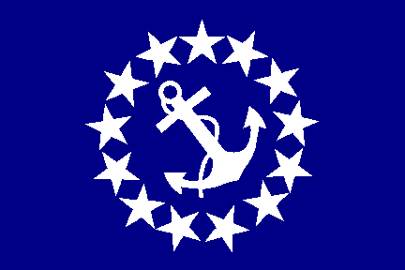 Commodore: antonia depascale

It’s that time a year again! The first function of the year is a week away. The entire bridge is excited for the 2023 season! Our first function is our Pot Luck so please bring your favorite dish to share. One final reminder to check the LCYC website for updates as it’s our best tool to get all information quickly to our members. Looking forward to seeing you all at the Marina!
Your commodore,
Antonia

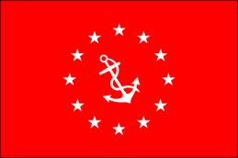 vice commodore: bobby andrade

Hi LCYC Member’s

Hats off to our Past Commodore Bill Sullivan!! Great change of watch went down in Norfolk. Thanks to all who helped and attended this event!!

It’s that time of year #Spring has Sprung!! Time to get 2023 boat season into high gear! Knock down last year’s cobwebs and ice down the cooler’s and fire up the old trusty vessel while crossing your finger

The first function as well as the “Blessing of the fleet” will be here before you know it!

Catch Y’all at D Rivah
Bobby Andrade, Jr.

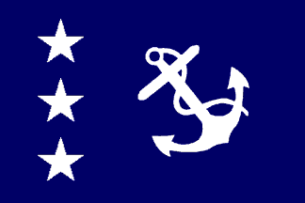 IMMEDIATE PAST Commodore: BILL SULLIVAN

First off, I would like to thank everyone who braved the elements to attend our Change of Watch. Hats off to all that helped in the logistics, setup, and the prep work. Special thanks need to go out to Dave Teets for the great job being our Master of Ceremony and always willing to take on the task! Thanks to Rod Dog for keeping everyone on the dance floor. Thank you to my outgoing Bridge for a job well done. Congrats to Rodney for making member of the year, well done.

Secondly, I would like to wish the incoming bridge the best of luck for the upcoming season. Don't forget the pot luck, blessing of the fleet coming next weekend, hope to see y'all there.

Bill Sullivan, Past Commodore

TREASURER: JAYNE MILLER

Finally the temperatures are rising and the boats are returning to their slips at the marina. Hopefully you will be able to attend the covered dish dinner and/or the Blessing of the Fleet breakfast on the weekend of April 22. After a long winter break it will be fun to visit with our marina family again.

Unfortunately we did not have a big turnout for the Change of Watch, resulting in a shortage of funds taken in to pay for the event, thus being a bit over budget for this function. Please consider attending next year, it is a nice break and a lot of fun to get together with friends you haven’t seen over the winter.

The current balance for the checking account is $4,713.36, pending deposits of $395 and the savings account balance is $5,005.01.

Jayne Miller, Treasurer

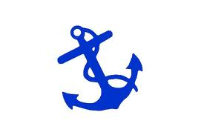 FLEET CAPTAIN: JAMES (COACH) PULCHINE

June 24th Beach Party. Details to follow!

SECRETARY: theresa sullivan

Roster and Membership cards will be complete by next week. If you do not see your name in the Roster it is because we have not received your membership renewal. If you are planning on joining, please send your dues as soon as possible. Thanks!

Newsletters, function dates, and any important information will be located on the website starting this month. Please check the website as often as possible.

SHIP STORE: Lori rappa

Ship Store is back!

New Inventory: T-shirts, tanks and hats in exciting new colors. I will be placing an additional order soon. So if you do not see what you want, I may be able to make a special order.

Looking forward to seeing y'all soon.

Lori

FROM YOUR DOCK DIRECTORS

C DOCK DIRECTOR: LAURA HENSON

Hello C-dock!

Unfortunately, Ken & I will not be able to attend the April potluck event as we have another commitment.

Let’s get together over Memorial Day weekend to discuss our plans for the C-dock event on June 10th.

Thanks!

Laura

D DOCK DIRECTOR: KENNY

Spring has sprung, and things have been bustling on D Dock already in 2023. Andy and I did a major service on our "little boat" over the winter, and we're excited to take her out for the first time in a few years soon (especially to Coach's Beach Party in June!). Andy and Robert have been tuning up their boats, and the plan is to take more trips this summer, spending nights out on the hook. And as if that wasn't enough, the guys have been doing a deep spring cleaning and some refurbishments to the Tiki bar over the past few weeks, and we're looking to make some more "upgrades" over the summertime. Let's just hope the weather also agrees with our plans!

D Dock is also happy to announce our plans to bring back the D Dock Oyster Roast on October 21st! Since there were going to be changes to the schedule for this year anyway, we decided to move our function back to October, which could then only mean.....Oysters! So mark your calendars now because it's sure to be a good time!

-Kenny D

WEBMASTER REPORT

As many of you probably know, Rob Van Arsdale created and maintained the LCYC website for a number of years (and did a great job of it to boot!). Rob and I had some discussions a few years back about how he set it up, as well as what being the webmaster entailed, since I had some experience building and hosting various websites for both personal and professional use. I had expressed interest in either helping out or taking over the webmaster duties from him, if he ever got tired of having the responsibility. Those conversations almost always ended with something along the lines of, "Well one day I'll get tired of it. Then it'll be your problem, since you're the only other person down here that's ever expressed interest."

Unfortunately, that time came way sooner than I expected, and obviously not the way I'd ever hoped the transition would happen. It took some time and effort to gain access to the backend of the website, but over the past months I've been going through the website and updating where necessary. As with most websites, it's a continual work in progress and I'm always open to suggestions. At the moment I'm looking into some sort of calendar/event plugin so that we can manage all LCYC functions right from our own website. Essentially the idea is the website would function as a replacement for Evites. The constraint is always, like most other things, time and money.
I would be remiss not to mention that without Rob and his technical expertise, the www.lodgecreekyachtclub.com website might not even exist. I hope that I am making him proud by keeping the website going in his honor and for everyone to enjoy. If you have any suggestions or requests about anything website related, feel free to chat with me about it at the marina sometime!

-Kenny D
LCYC Webmaster

UPCOMING REMINDERS

Boat Virginia Course, FREE, Saturday, May 27, at the Olverson’s clubhouse from 8:00 AM to 5:00 PM. Passing this course ins required to operate a power boat with more than 10 hp or to operate a jet ski (PWC). You must also be 14 or older to operate a PWC.

The Richmond Sail and Power Squadron is offering a Marine Navigation course starting April 13. This is an 8-night course that covers navigation with chartplotters and includes charts, aids to navigation, the marine compass, and use of chartplotter for navigation. The course includes practical examples using chartplotters and manual techniques. Students must have a laptop or tablet (no Apple iOS) and access to the internet to download instructional materials and participate in the on-line instruction on Zoom. The course costs $100 and with run each Thursday evening from 7:00 to 9:00 PM from April 13 to June 1. To sign up, contact Bill Simpson at bcsimpson1@aol.com.

Dave Teets (Southern Cross – 804-370-7061) and Jim Zeigler (Tortuga -0804-347-5239), both on C-Dock will be available over the spring and summer to provide courtesy Vessel Safety Checks (VSC). This is a US Coast Guard program to help you determine if you have the required safety equipment on your boat. This is a courtesy check and not a law enforcement activity.

The Richmond Sail and Power Squadron invites Lodge Creek members to participate in a cruise to Norfolk, Hampton and Yorktown. The first organized activities will be July 3 at Tidewater Marina across from Waterside and you can join us for a Norfolk Tides Ball Game. July 4th fireworks will be directly overhead. The group will then move to Bluewater Yachts in Hampton on July 5 and Riverwalk Landing in Yorktown on July 7, returning home on the 9th. If you are interested, contact Jim Zeigler at 804-347-5239 or jim@jpzeigler.com.

________________________________________________________________________

FROM THE SAFETY OFFICER

VESSEL SAFETY CHECKS FOR ALL BOATERS
Vessel Safety Checks are FREE and very important for all boaters to obtain one each season! These checks are done by certified Vessel Safety Check examiners and take about 20 minutes. Once you pass a VSC, you receive a certification sticker that is displayed on your boat and shows law enforcement that your vessel has passed for the 2023 boating season. To learn more about a Vessel Safety Check, feel free to talk with the two Certified VSE examiners that are based out of Lodge Creek Yacht Club-Jim Zeigler (C-22) and Dave Teets (C-24). Your boat needs to have Coast Guard safety equipment on board along with proper registration or documentation. Navigation lights and boat horn needs to be working as well.

Contacting the Marina Office, or Dave or Jim is all you need to do to get an examination at your convenience. Remember, try to obtain a VSC exam before the boating to help insure your safety throughout the boating season. These examiners provide a lot of useful information and can help you with many of your boating questions also!!!

VIRGINIA BOATING SAFETY CERTIFICATION CLASS - MAY 27TH !!!'

Annually, Olverson's Marina and Lodge Creek Yacht Club sponsor the required Certified Virginia Boating Safety Class for any boater that has not yet taken an approved Boating Class. As most people know, any boater operating a vessel over 10 HP is required to have taken an approved class and must also be able to display proof when requested to do so. WE offer this class FREE of charge and the Marina provides a FREE lunch as well! The class is an 8 hour class and at the end of the class, participants can obtain their certification card as well. Boaters are required to take an approved class only once, so no need to renew your certification card. Saturday, May 27th, 8am-5pm and simply sign up at the Marina office to register. Any questions, simply give Dave Teets a call at 804-370-7061.

Thanks,

Dave Teets

PAST COMMODORES

2022 Bill Sullivan
2021 Bob Woodburn
2020 Jay Novak
PAST COMMODORES

2019 Barbara Woodburn
2018 William Ward
2017 William Weber
2016 Ed Rest
2015 Bill Sullivan
2014 Steve Thompson
2013 George Utt
2012 Theresa Sullivan
2011 Bruce Williamson
2010 David Teets
2009 Tony Andrade
2008 Bob Ryan
2007 Sarah Harman-Hopkins
2006 Ed Rest
2005 Jerry Hopkins
2004 J.T. Taylor
2003 Ed Williams
2002 David Deal
2001 Tom Redford
2000 Mike Steele
1999 Parker Carwile
1998 Ken Brooks
1997 Byrd Chancey
1996 John Phipard
1995 Ellie Culbertson
1994 Bill Selden, V
1993 Ron Sowers
1992 Dick Roop
1991 Charles "Skip" Campbell
1990 Sandy Campbell
1989 George Thompkins
1988 Susan Secoy
1987 Lee Bedsoe
1986 Wayne Burgess
1985 Mason Cole
1984 Bud Ziherl
1983 Wayne Hedges
1982 A.B. Skepstedt
1981 James Harper
1980 John Gupton
1979 James Bricker
1978 Jimmy Morrison
1977 Charles Winder
1976 Gene Kohler
1975 Melvin Duke
1974 Joe Giannotti
1973 Bob Costner
1972 Leo Huckstep
1971 Leo Huckstep

INFO TO REMEMBER

LCYC Website link: http://www.lodgecreekyachtclub.com/
For quick access to the Roster and dock assignments the link is:
http://www.lodgecreekyachtclub.com/members/ (Password Protected)

BOATERS SAFE BOATING COURSE - Effective July 1, 2019 all Virginia boater must have taken a Certified Boaters Safe Boating Course and have proof of this while boating in Virginia waters while operating any vessel powered by a motor of at least 10 hoursepower. This law makes no distinction of age or experience.

As we start the boating season, we must all renew our commitment for SAFE BOATING.

VESSEL SAFETY CHECKS - The most cautious boaters can sometimes experience unexpected problems on the water. That's why the U.S. Coast Guard recommends that all recreational boaters, including personal watercraft and paddle sport users take advantage of the free Vessel Safety Check Program every year. We have certified Vessel Safety Check Examiners here at Olverson's Marina. Please contact the Marina Office and office personnel will provide you with contact information for getting this free examination. Once you have completed this free 15-minute examination, you will be given a decal that can proudly be displayed on your vessel. Taking a few minutes to have your vessel checked, just may save you from problems this season!

MEMBERSHIP RENEWAL

Annual Membership Fees are due on December 31st

Annual Membership Fee - $100

Annual Membership Late Fee - $20 if paid after January 31st.

